
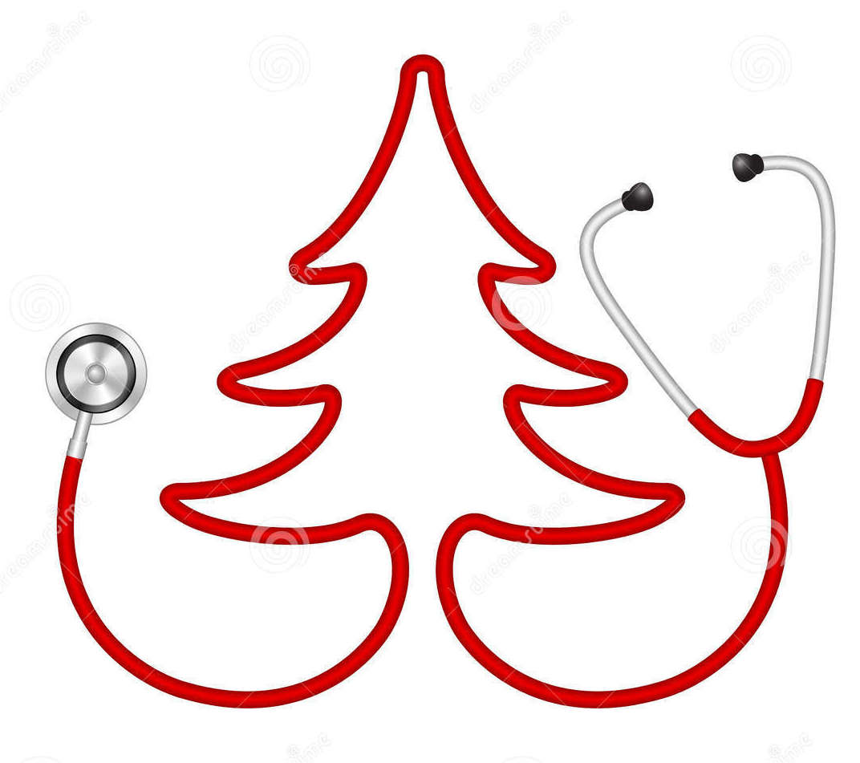
Free Emergency Contraception for under 25’s
over the Christmas & New Year public holidays 2017/18
If you have sex without using contraception, or if there is a risk that your contraception may have failed (eg, split condom, forgotten a pill), then you can use emergency contraception to prevent a pregnancy.
Under 25’s can access free EHC up to 120 hours (5 days ) after unprotected sex, however we recommend accessing services as soon as possible to increase effectiveness.
Sunday 24th December  Christmas Eve
Boots North Street | 129 North Street, BN1 2BE | 01273 207461 | 11am – 5pm
Weston’s Pharmacy | 5,6 & 7 Coombe Terrace, BN2 4AD | 01273 605354 | 9am – 10pm
Ashton’s Pharmacy | 98 Dyke Road, BN1 3JD | 01273 325020 | 9am – 10pm
Monday 25th December Christmas Day
Weston’s Pharmacy | 5,6 & 7 Coombe Terrace, BN2 4AD | 01273 605354 | 9am – 10pm
Ashton’s Pharmacy | 98 Dyke Road, BN1 3JD | 01273 325020 | 9am – 1pm
Tuesday 26th December Boxing Day
Boots North Street | 129 North Street, BN1 2BE | 01273 207461 | 9am – 6pm
Weston’s Pharmacy | 5,6 & 7 Coombe Terrace, BN2 4AD | 01273 605354 | 9am – 10pm
Ashton’s Pharmacy | 98 Dyke Road, BN1 3JD | 01273 325020 | 9am – 10pm
Sunday 31st December  New Years Eve 
Boots North Street | 129 North Street, BN1 2BE | 01273 207461 | 11am – 5pm
Weston’s Pharmacy | 5,6 & 7 Coombe Terrace, BN2 4AD | 01273 605354 | 9am – 10pm
Ashton’s Pharmacy | 98 Dyke Road, BN1 3JD | 01273 325020 | 9am – 10pm
Monday 1st January 2018  New Years Day
Boots North Street | 129 North Street, BN1 2BE | 01273 207461 | 10am – 4pm
Weston’s Pharmacy | 5,6 & 7 Coombe Terrace, BN2 4AD | 01273 605354 | 9am – 10pm
Ashton’s Pharmacy | 98 Dyke Road, BN1 3JD | 01273 325020 | 9am – 10pm
Boots Boundary Road | 67 Boundary Road, BN3 5TD | 01273 414027 | 10am – 4pm
Parris & Greening Pharmacy | 105 Church Road, BN3 2AF | 01273 732216 | 9am – 6.30pm

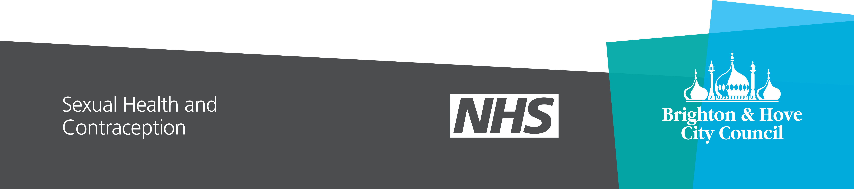
*We recommend you contact the pharmacy before visiting to check there is a pharmacist available.
*We recommend you contact the pharmacy before visiting to check there is a pharmacist available.

